Are you interested in research
about primary care and emergency care?

Would you like to work with researchers in Wales
to plan and carry out research on these topics?
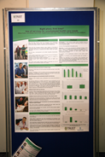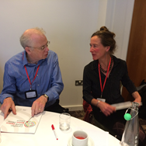

We are recruiting patients, carers and members of the public to be involved in research carried out by members of PRIME Centre Wales, the research centre which develops and undertakes research about primary and emergency care services. These are the health services you receive from your local health centre, at home or when you call 999.

We are looking for people with different backgrounds and experiences to reflect the diverse perspectives of people who live in Wales. We are setting up a group to advise us, work with us and be involved in research proposals and projects. We will offer an honorarium to acknowledge your commitment and reimburse expenses you incur by being involved. We can also provide a mentor to give support and advice to anyone who has not been involved in research before.

Being involved in research means members of the public are actively involved in research projects and in research organisations, for example: in identifying research priorities; as members of a project advisory or steering group; by commenting on and developing patient information leaflets or other research materials. This is different from participating in research, for example: when someone takes part in a trial or answers a questionnaire.

We are looking for people with the following experiences, skills and interests:
- You have experience of primary or emergency care as a patient, carer or public member, or you think you may use these services in the future. You are also able to set aside any personal agenda – this isn’t a chance to complain or seek specific changes to your care
- You understand what being involved in research means and you want to be involved in research by helping us plan projects and giving us feedback on ideas and written information that we share with you
- You are willing to prepare for and take part in meetings. These will be up to four times a year, probably in Swansea or Cardiff. Ideally, we’d like most people to attend in person. When this is difficult, you can also email your views or talk to us on the phone. You can also take up occasional opportunities to be involved in extra activities, between these meetings
- You have good communication skills – you can make relevant comments in a clear, constructive and courteous way. You listen to others without judging and can work cooperatively and consensually with people from diverse backgrounds
- You are willing to ask for information and clarification and to take up training which is provided. We will also ask you to join the Involving People network if you aren’t already a member, so you can access support, training and other information
- You are able to use email, as papers for meetings will be sent out this way. You will also be able to participate in online discussions between meetings

This is an occasional commitment, roughly a few hours each month but probably not spread evenly, with busier and quieter times.

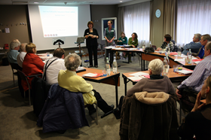 |  |  | 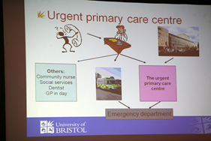

PRIME Centre Wales is a research centre focusing on primary and emergency care, funded by Health and Care Research Wales in order to develop and coordinate research proposals and support researchers. It is an all-Wales centre co-led by Cardiff University, Bangor University, University of South Wales, and Swansea University. There is more information at http://www.primecentre.wales/

You can find more information about being involved in research at http://www.invo.org.uk/ and https://www.healthandcareresearch.gov.wales/what-is-public-involvement-in-research/

For more information on joining the Health and Care Research Wales Involving People Network please see https://www.healthandcareresearch.gov.wales/public/
If you are interested in being involved in our research, please provide the following information
Name
Address
Email address
Telephone number
What relevant experience do you have?
Why would you like to be involved in this group?

If you want more information before you fill in this form, please email Bridie (b.a.evans@swansea.ac.uk)
and we can email or phone you back for an informal chat.

Please post or email your information to:
Bridie Evans
Swansea University Medical School
2nd floor ILS2
Singleton Campus
Swansea SA2 8PP
b.a.evans@swansea.ac.uk

Please return your information by: Tuesday September 13th, 2017

